4. system Maintenance 4-1
System Configuration 4-1
LINKED TABLES 4-5
Linking to a New Database 4-6

FILE IS C:\WORK\SCMgr\Documents\new manual\SCMgr-sec4.doc
TEMPLATE IS MANUAL.DOT

This is an information page. Do not include it in the finished manual.

This is an information page. Do not include it in the finished manual.

system Maintenance

Before Supply Chain Manager can help manage distribution, you must define the distribution system. This section outlines the steps needed to set up Supply Chain Manager to manage the distribution system.

- From the main menu, select the System Maintenance option.

System Configuration
The System Configuration form outlines the design of your distribution system. System configuration must be defined when you use Supply Chain Manager for the first time.

- From the System Maintenance menu, select the System Configuration option.

The System Configuration form (Figure 4-1) is displayed.
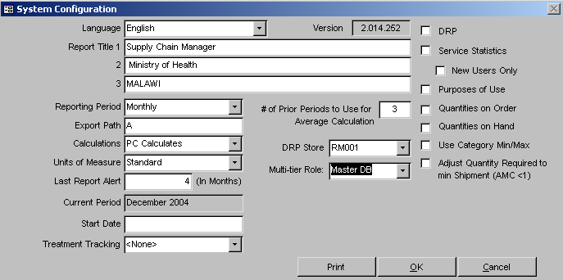
Figure 4-1 – System Configuration form
 | Changes to the System Configuration form may change Supply Chain Manager's effectiveness. Consult your logistics officer or system administrator before modifying data in the System Configuration form.

The Version field is defined by the system and cannot be changed.

The Current Period field identifies the current reporting period. You cannot change this field from within the System Configuration form. The current period is changed whenever a new period is selected for data entry in the Product Tracking form.

The Report Titles fields enable you to enter banners that are printed at the top left of all reports you generate; for example, the names of the department and organization managing the distribution system.

- Click one or more Report Titles fields, and type text to be displayed on all Supply Chain Manager reports.

The # of Periods To Use For Average Calculation field lets you specify how many reporting periods Supply Chain Manager will use when calculating average monthly consumption.

- Click the # of Periods To Use For Average Calculation field and type the number of reporting periods.

The Reporting Period field lets you define the length of a reporting period.

- Click on the arrow next to the Reporting Period field, select a reporting period from the pull-down menu, and click the left mouse button.

The Calculations field lets you determine how Supply Chain Manager performs calculations. Calculations can be performed as follows:
- Supply Chain Manager performs all calculations.
- You perform all calculations and let Supply Chain Manager validate them.
- You perform the calculations without validation.

By default, Supply Chain Manager performs all calculations.

- Click on the arrow next to the Calculations field, select a calculation option from the pull-down menu, and click the left mouse button.

The Units Of Measure field lets you select the unit of measure Supply Chain Manager will use. The available units of measure are (1) Standard (English system) and (2) Metric.

- Click on the arrow next to the Units Of Measure field, select a measuring unit, and click the left mouse button.

The DRP checkbox lets you use the DRP Module for distribution monitoring.

- Click the checkbox to use the DRP Module for distribution planning.

The DRP Store field lets you define the distribution center that will distribute products using the DRP module.

- Click on the arrow next to the DRP Store field, select a distribution center, and click the left mouse button.
 | Leave the DRP Store field blank if you are only using the Product Tracking module.

The Service Statistics checkbox lets you collect service statistics—new users and continuing users—for each product you track.

- Click the Service Statistics checkbox to enable the collection of service statistics.

The New Users Only checkbox underneath the Service Statistics checkbox lets you collect data on new users only. Collecting data on expected new users for each product you track enables you to augment current consumption to meet rising demand for products such as antiretroviral drugs.

- Click the New Users Only checkbox to enable the collection of statistics on new users only.

The Purposes of Use checkbox lets you collect data on one or more purposes of use for each product dispensed. For example, HIV test kits may be used for multiple purposes—voluntary counseling and testing (VCT), prevention of mother-to-child transmission (PMTCT), or clinical diagnosis. When this feature is activated, Supply Chain Manager records quantities of each product dispensed by purpose of use, in addition to the total quantities dispensed as reported by the facility.

- Click the Purpose of Use checkbox to enable the collection of data on quantities of products dispensed by purpose of use.

The Quantity on Order checkbox lets you record quantities of each product on order. These quantities are then subtracted from the calculation of quantities required of each product to bring a facility up to the maximum stock level.

- Click the Quantity on Order checkbox to enable the collection of data on quantities of products on order.

The Quantity on Hand checkbox lets you determine if the shipment date field will be presented on the Product Tracking form.

- Click the Quantity on Hand checkbox to display the shipment date field on the Product Tracking form.

The Use Category Min/Max checkbox gives you the ability to set minimum and maximum stock levels for each category associated with an individual facility.

- Click the Use Category Min/Max checkbox to set minimum and maximum stock levels for your facilities.

The Adjust Quantity Required to min Shipment (AMC <1) checkbox lets you determine if products with traditionally small AMCs (>0 and <1) be rounded up to one (1) instead of rounded down to zero (0).

- Click the Adjust Quantity Required to min Shipment (AMC <1) to allow for products with traditionally small AMCs (>0 and <1) be rounded up to one (1).

The Multi-tier Role field lets you determine roles in a multiple tier system based on the following options:
- None: Not a Multiple Tier System
- Master DB: The central level of the Multiple tier system
- Client DB: A lower level data center that enters the tracking data
- Read Only: A complete copy of the system that cannot be written to

Selecting the Master DB, Client DB or Read Only option will enable you to use the Multi-tier Reporting Tools menu to create a multi-tier reporting system. Before you do this, however, you will need to define your facilities, products, categories and other pertinent background data. After you define your background data, you may return to the System Maintenance form to set up your multi-tier system.
See Section 6 – Multiple Level Reporting (Multi-Tier for more information on creating a multi-tier system.

- Click on the arrow next to the Multi-Tier Role field, select a role from the pull-down menu, and click the left mouse button.

The Start Date field lets you set a semi-permanent starting date Supply Chain Manager should use as a default starting date for facilities.
 | This should not be confused with the date system used by your computer.

- Click in the Start Date field and enter the starting date you want you facilities to use as the default date.

The Treatment Tracking field lets you determine which (if any) tracking fields will be available from the Product Tracking form based on the following options:
- None: No tracking fields present
- TB: Tracking fields as defined for Uganda’s TB program
- ART: Tracking fields for Uganda ART program

- Click on the arrow next to the Treatment Tracking field, select a tracking option from the pull-down menu, and click the left mouse button.

The Last Report Alert field applies to the estimation of facility need in the DRP module. It lets you set the maximum time period since the last reported stock count in which need can be estimated for a particular facility.

- Click the Last Report Alert field and type the number of months since the last stock count in which a facility’s need can be estimated.

The Print button sends a copy of the System Configuration form to the printer. If you do not have access to the Supply Chain Manager software, you can use this report to review Supply Chain Manager’s configuration.

- Click Print to print the System Configuration form.

- Click OK.

LINKED TABLES
This option lets you update the location of Supply Chain Manager’s database tables. When you first install Supply Chain Manager, the database tables are installed by default in the C:\Programs Files\SCMgr\Data directory or the directory you specified for installation. You can use this option to view other Supply Chain Manager databases.

- In the System Maintenance menu, select the Linked Tables option.

The Linked Tables form (Figure 4-2) is displayed.
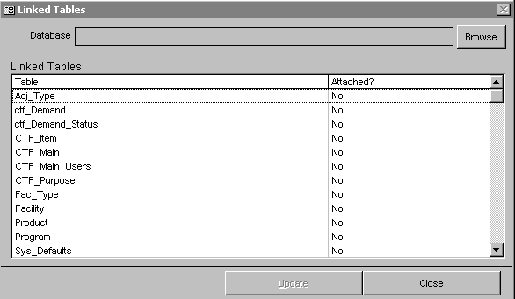
Figure 4-2 – Linked Tables form

- Click on the Browse button.

The Select Database to Link to window is displayed. This is a standard Windows file selection window.

- Locate the database you want to link to (it will have the extension ".mdb").

- Select the database and click on the Open button.

 | If the selected Data file is not the currently linked data file (or if no data file has initially been selected) the status for each table will show a "No" under the Attached column as shown in Figure 4-2 above.

The Update button becomes enabled after you select the data file you want to link to.

- Click the Update button to link the tables of the selected data file to Supply Chain Manager.

Linking to a New Database
Supply Chain Manager is installed with a database that contains sample data. Also included in the installation is a new database that contains no data. You can review the features of Supply Chain Manager with the sample database. When you are ready to use Supply Chain Manager to track the f low of products in your distribution system, you can open the new database and start entering data.

- To Create a new database, make a copy of the SCM_BE_Blank.mdb file located in the c:\program files\SCMgr\Template directory and save it to the c:\Program Files\SCMgr\Data\ directory with a meaningful name (keeping the .mdb extension).
- To open the database click the newly created database located in the c:\Program Files\SCMgr\Data\ directory.

- Click Open.

